**Project Design Phase-II**

|  |  |
| --- | --- |
| Date | 20 October 2022 |
| Team ID | PNT2022TMID31830 |
| Project Name | University Admit Eligibility Predictor |
| Maximum marks | 4 marks |

**Data Flow Diagram & User Stories**

**Data Flow Diagrams**:

A Data Flow Diagram (DFD) is a traditional visual representation of the information flows within a system. A neat and clear DFD can depict the right amount of the system requirement graphically. It shows how data enters and leaves the system, what changes the information, and where data is stored.

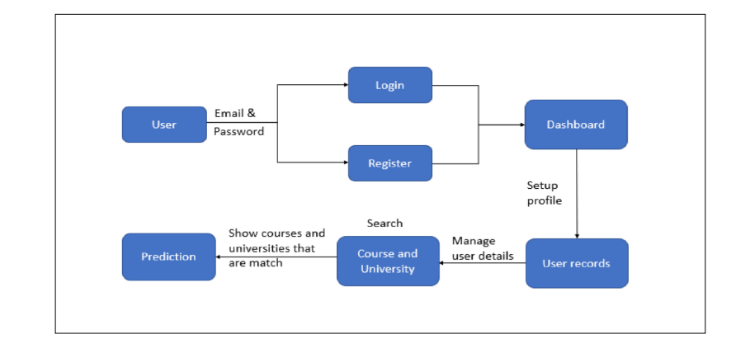

**User Stories**:

Use the below template to list all the user stories for the product.

|  |  |  |  |  |  |  |
| --- | --- | --- | --- | --- | --- | --- |
| **User Type** | **Functional Requirement (Epic)** | **User Story Number** | **User Story / Task** | **Acceptance criteria** | **Priority** | **Release** |
| Customer | Registration | USN-1 | As a user, I can register for the application by entering my email, password, and confirming my password. | I can access my account / dashboard | High | Sprint-1 |
|  |  | USN-2 | As a user, I will receive confirmation email once I have registered for the application. | I can receive confirmation email & click confirm | Medium | Sprint-1 |
|  |  | USN-3 | As a user, I can register for the application through Gmail. |  | Medium | Sprint-1 |
|  | Login | USN-4 | As a user, I can log into the application by entering email & password. |  | High | Sprint-2 |
|  | Dashboard | USN-5 | As a user, I can access my dashboard. | I can access my account / dashboard | High | Sprint-2 |
|  | Input | USN-6 | As a user, I can setup the profile and basic details. I can enter my marks, qualifications and other requirements. | I can enter my details/requirements | High | Sprint-3 |
| Customer care Executive | Customer care | USN-7 | As an executive, I can solve the queries and issues. | I can give my support. | Low | Sprint-3 |
| Administration | Application | USN-8 | As an administrator, I can upgrade or update the application. | I can modify and improve the application. | High | Sprint-4 |